Novosibirsk State Technical University
Foreign Languages Department for Technical Faculties
Translation Programme
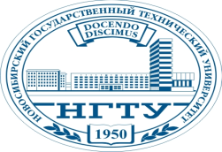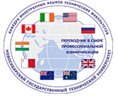

WEEK of TRANSLATION – 2017
COMPETITION IN FILM DUBBING
Place & Time:
Building 1, Conference Hall, September 29, 17:00
Participants:
Groups of Translation program students of all years of study
Assignment:
You work in groups. You choose an episode from a Russian well-known film/cartoon to show it to the audience on the day of the event. A 3 to 5 minute episode should be translated beforehand. You are free to dub it in advance or voice it during the film presentation at the event.
Criteria:
- Adequacy of translation
- Accuracy of translation
- Artistry of dubbing/voicing
- Audience emotional response
- English subtitles add to your total score.

Application:
Apply to kaf_iy_tf@corp.nstu.ru.

You can get assistance from your English teachers.

